Test Case: tc002_SPX_Dev5_Crear_Requisicion_Spot_Con_FAD_Tipo_Cobro_CC
Step 1 - Enter username and password and click to button Enter : Credentials Entered
Image file-name: QC_Testing-tc002_SPX_Dev5_Crear_Requisicion_Spot_Con_FAD_Tipo_Cobro_CC-1790175258493

Step 2 - Select to UEN and Access to Spot Buy Requisitions : UEN Correctly selected and Correct access
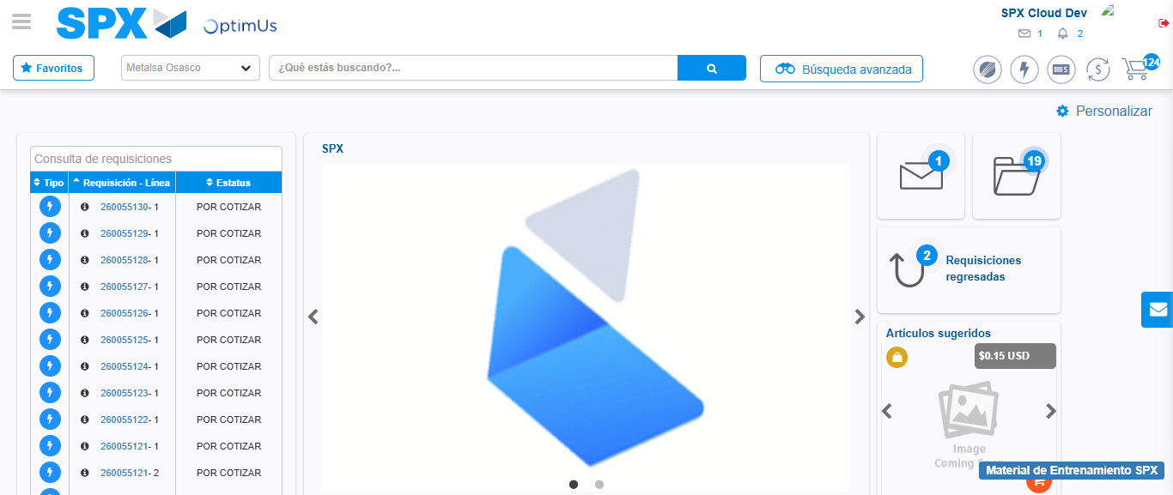Image file-name: QC_Testing-tc002_SPX_Dev5_Crear_Requisicion_Spot_Con_FAD_Tipo_Cobro_CC-1790175283578

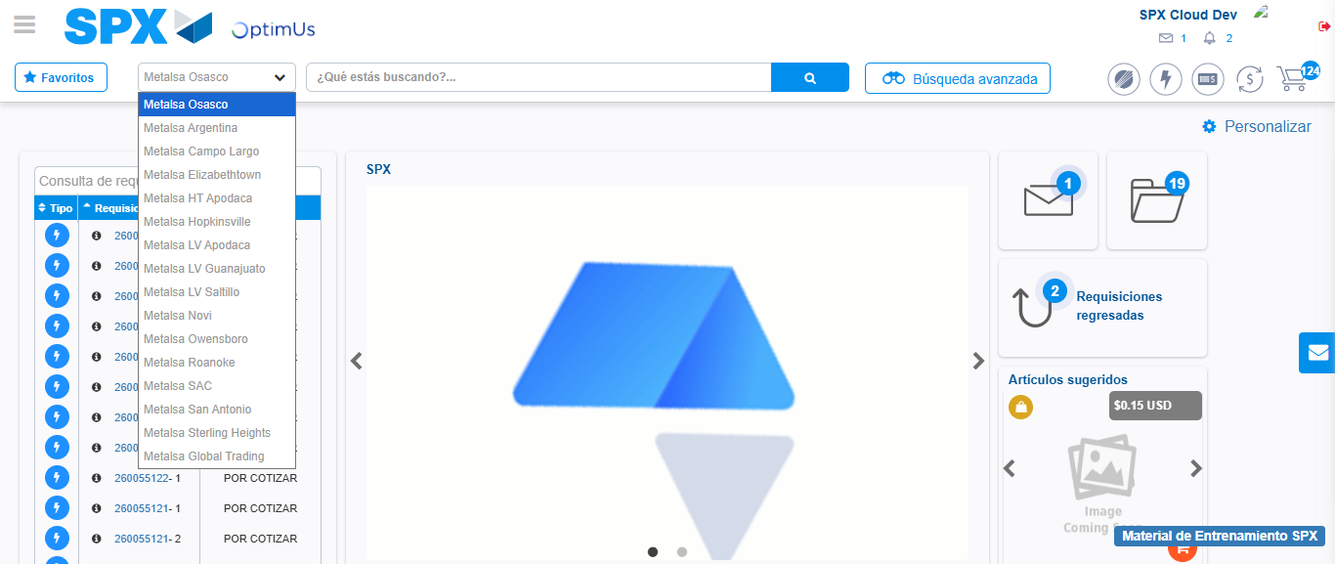Image file-name: QC_Testing-tc002_SPX_Dev5_Crear_Requisicion_Spot_Con_FAD_Tipo_Cobro_CC-1790175284424

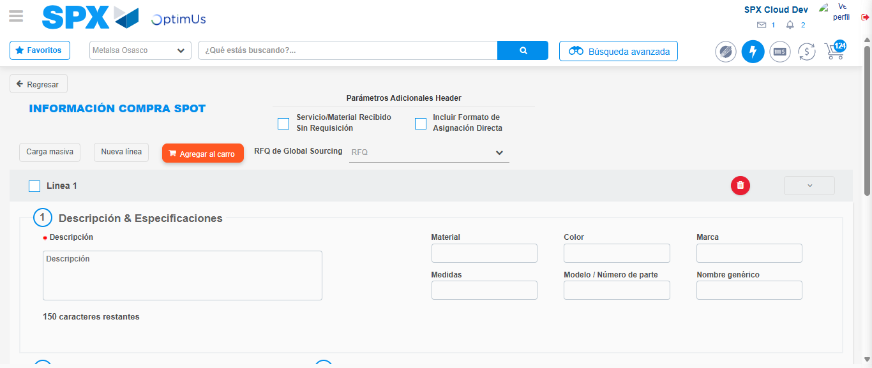Image file-name: QC_Testing-tc002_SPX_Dev5_Crear_Requisicion_Spot_Con_FAD_Tipo_Cobro_CC-1790175291075

Step 3 - Add FAD to Requisition: FAD Successfully Added
Image file-name: QC_Testing-tc002_SPX_Dev5_Crear_Requisicion_Spot_Con_FAD_Tipo_Cobro_CC-1790175291385

Image file-name: QC_Testing-tc002_SPX_Dev5_Crear_Requisicion_Spot_Con_FAD_Tipo_Cobro_CC-1790175291614

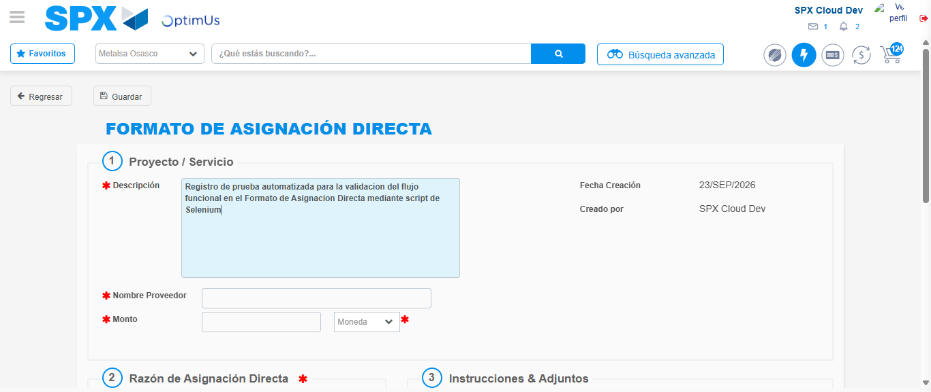Image file-name: QC_Testing-tc002_SPX_Dev5_Crear_Requisicion_Spot_Con_FAD_Tipo_Cobro_CC-1790175294755

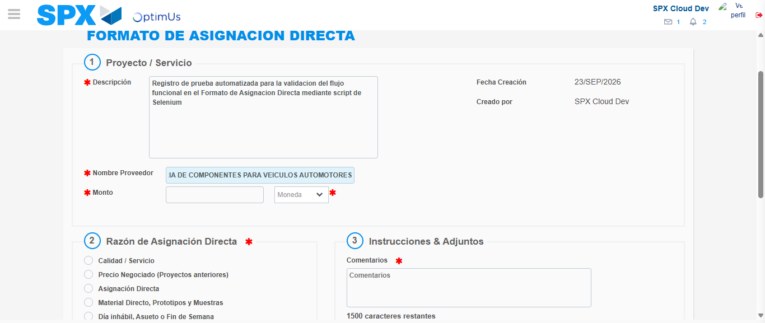Image file-name: QC_Testing-tc002_SPX_Dev5_Crear_Requisicion_Spot_Con_FAD_Tipo_Cobro_CC-1790175304485

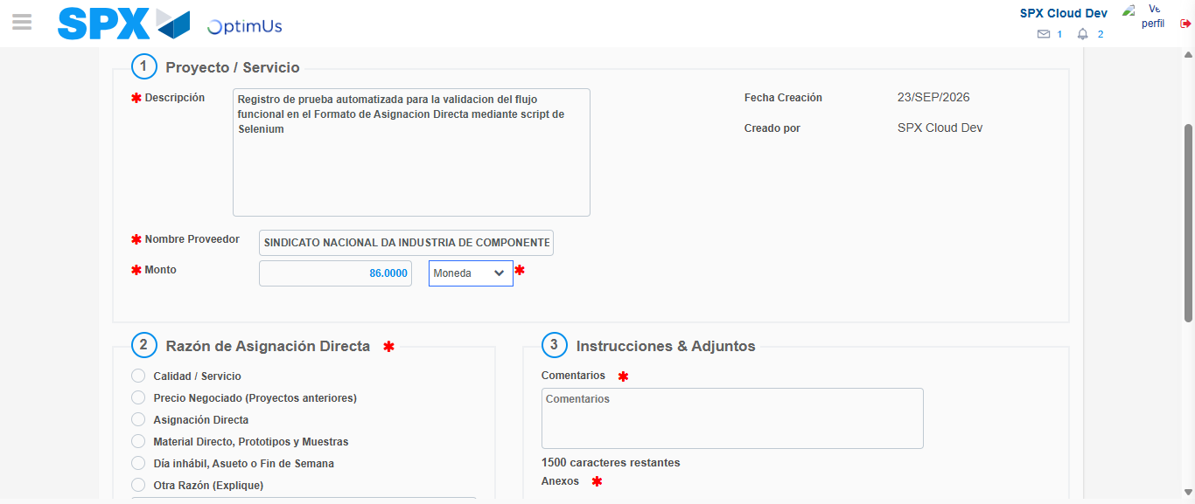Image file-name: QC_Testing-tc002_SPX_Dev5_Crear_Requisicion_Spot_Con_FAD_Tipo_Cobro_CC-1790175305084

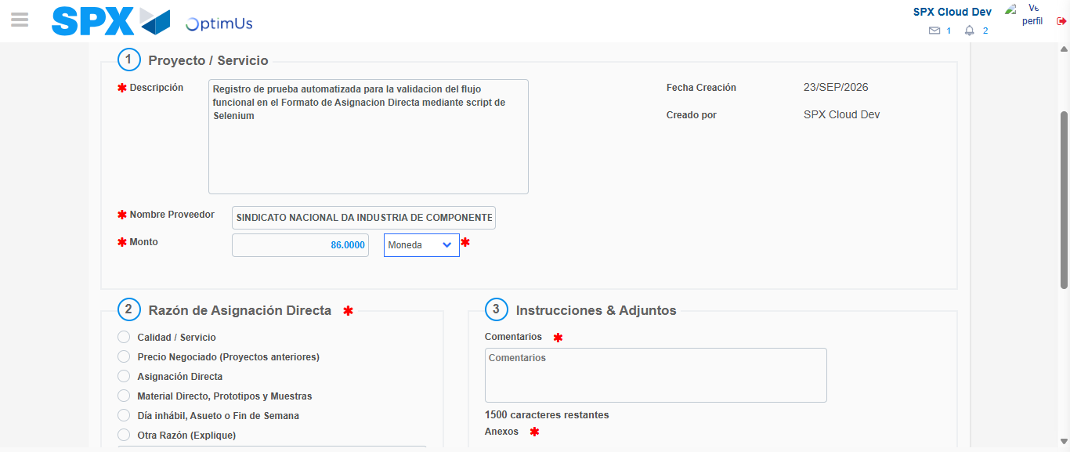Image file-name: QC_Testing-tc002_SPX_Dev5_Crear_Requisicion_Spot_Con_FAD_Tipo_Cobro_CC-1790175305335

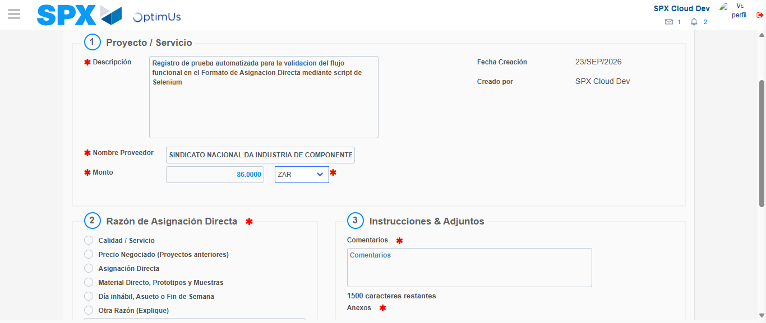Image file-name: QC_Testing-tc002_SPX_Dev5_Crear_Requisicion_Spot_Con_FAD_Tipo_Cobro_CC-1790175305764

Image file-name: QC_Testing-tc002_SPX_Dev5_Crear_Requisicion_Spot_Con_FAD_Tipo_Cobro_CC-1790175305981

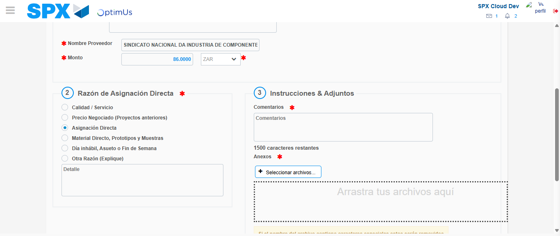Image file-name: QC_Testing-tc002_SPX_Dev5_Crear_Requisicion_Spot_Con_FAD_Tipo_Cobro_CC-1790175306862

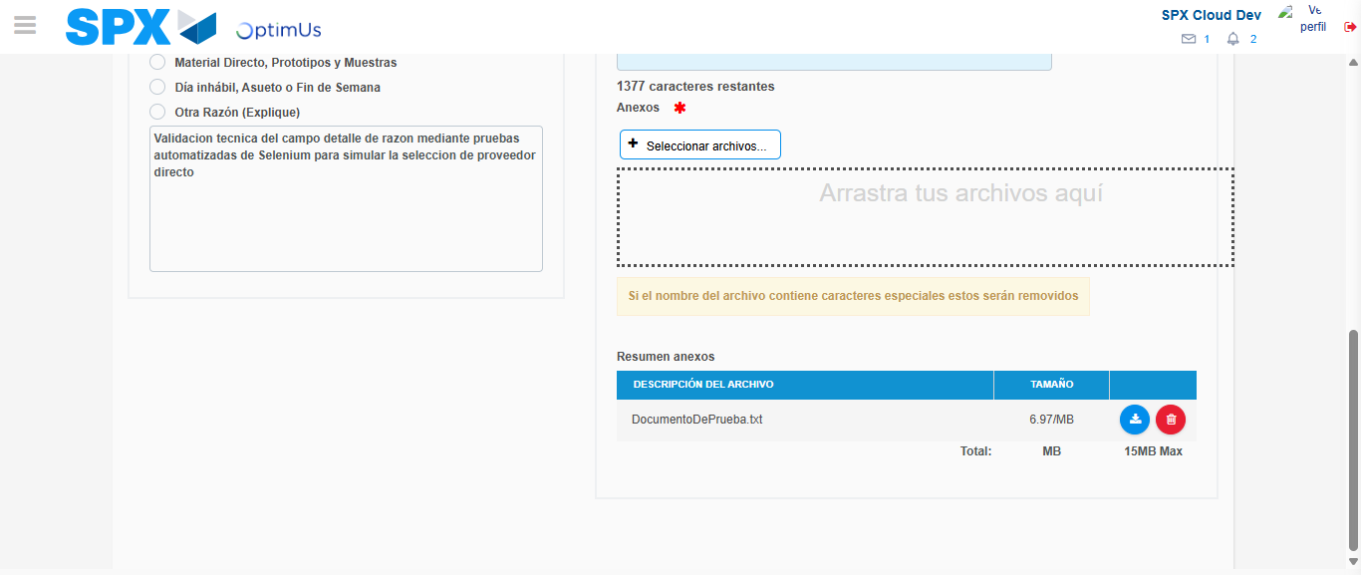Image file-name: QC_Testing-tc002_SPX_Dev5_Crear_Requisicion_Spot_Con_FAD_Tipo_Cobro_CC-1790175318318

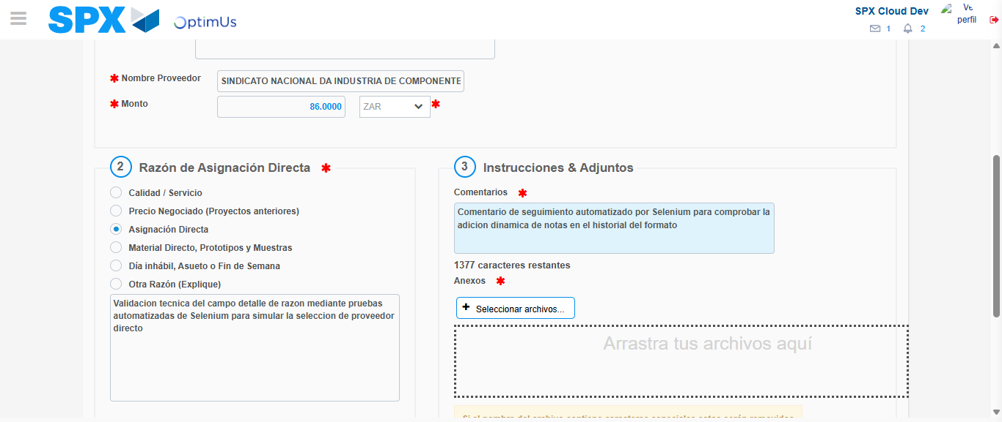Image file-name: QC_Testing-tc002_SPX_Dev5_Crear_Requisicion_Spot_Con_FAD_Tipo_Cobro_CC-1790175319143

Step 4 - Data Capture Spot Buy Requisition: Data captured correctly
Image file-name: QC_Testing-tc002_SPX_Dev5_Crear_Requisicion_Spot_Con_FAD_Tipo_Cobro_CC-1790175291385

Image file-name: QC_Testing-tc002_SPX_Dev5_Crear_Requisicion_Spot_Con_FAD_Tipo_Cobro_CC-1790175291614

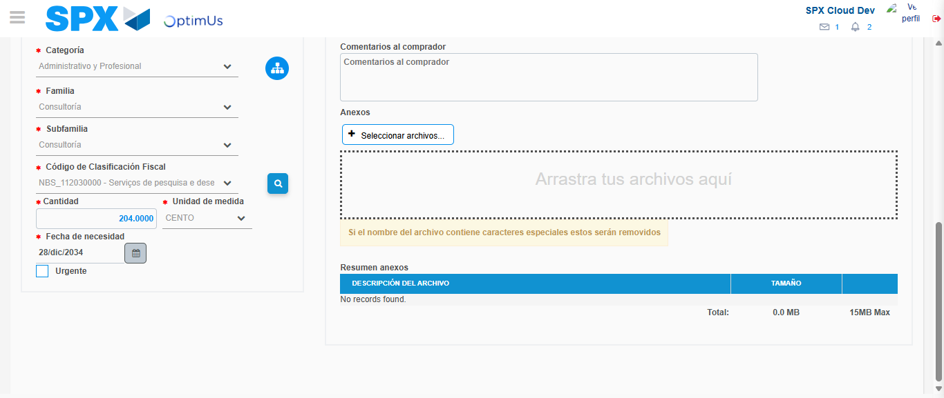Image file-name: QC_Testing-tc002_SPX_Dev5_Crear_Requisicion_Spot_Con_FAD_Tipo_Cobro_CC-1790175336417

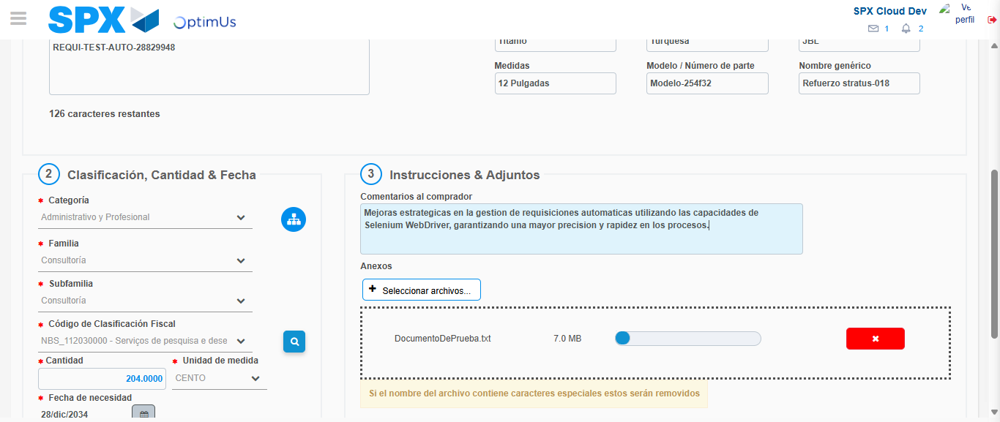Image file-name: QC_Testing-tc002_SPX_Dev5_Crear_Requisicion_Spot_Con_FAD_Tipo_Cobro_CC-1790175337234

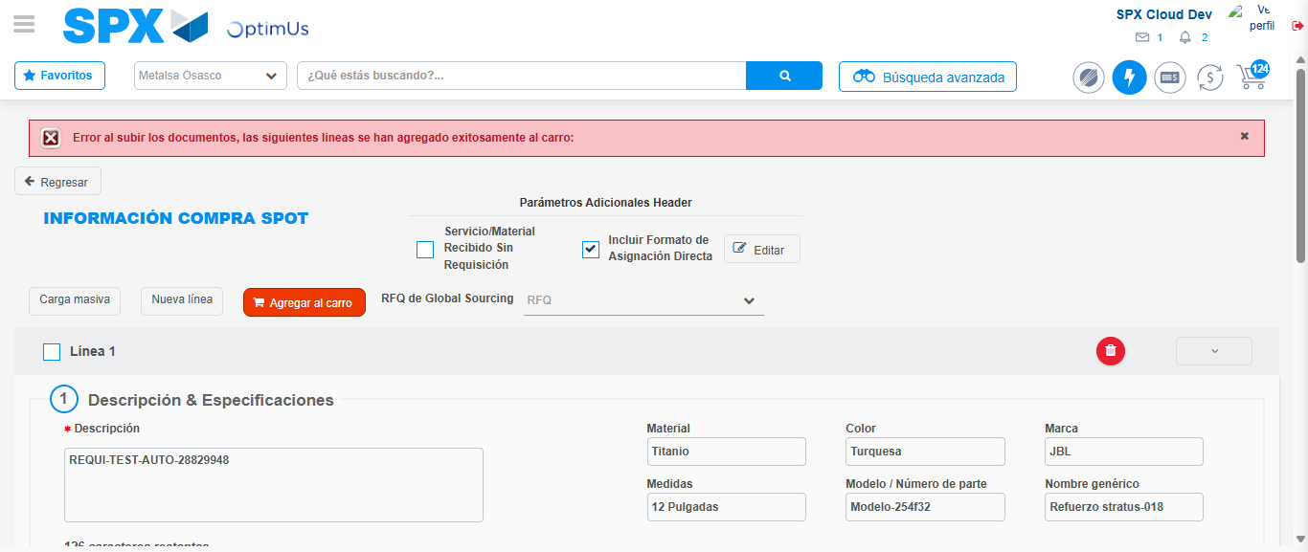Image file-name: QC_Testing-tc002_SPX_Dev5_Crear_Requisicion_Spot_Con_FAD_Tipo_Cobro_CC-1790175357274

Step 8 - Return to Main Page SPX : Return to Main Page SPX
Image file-name: QC_Testing-tc002_SPX_Dev5_Crear_Requisicion_Spot_Con_FAD_Tipo_Cobro_CC-1790175283578

Image file-name: QC_Testing-tc002_SPX_Dev5_Crear_Requisicion_Spot_Con_FAD_Tipo_Cobro_CC-1790175284424

Image file-name: QC_Testing-tc002_SPX_Dev5_Crear_Requisicion_Spot_Con_FAD_Tipo_Cobro_CC-1790175291075

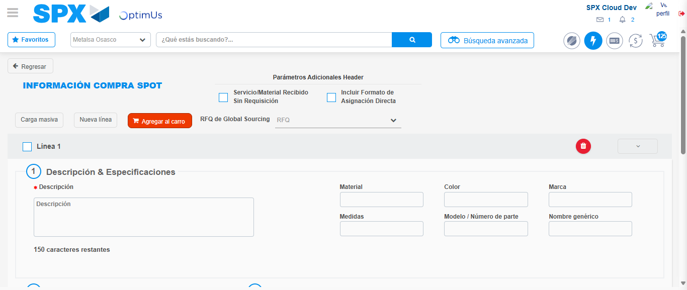Image file-name: QC_Testing-tc002_SPX_Dev5_Crear_Requisicion_Spot_Con_FAD_Tipo_Cobro_CC-1790175371198

Image file-name: QC_Testing-tc002_SPX_Dev5_Crear_Requisicion_Spot_Con_FAD_Tipo_Cobro_CC-1790175371396

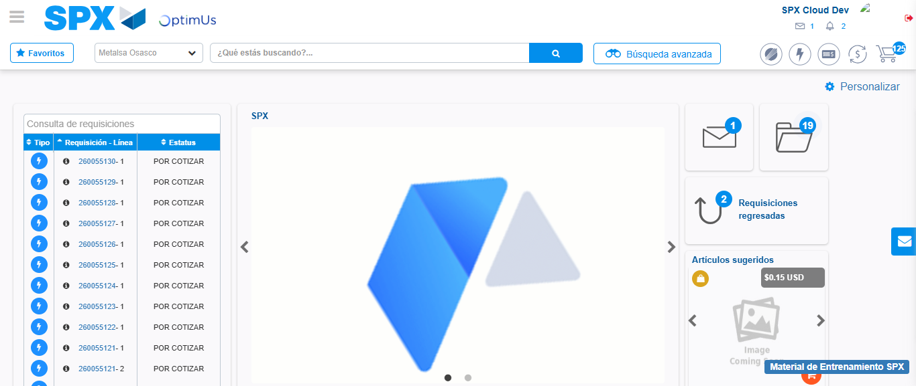Image file-name: QC_Testing-tc002_SPX_Dev5_Crear_Requisicion_Spot_Con_FAD_Tipo_Cobro_CC-1790175392665

Step 9 - Log Out : Log Out SPX
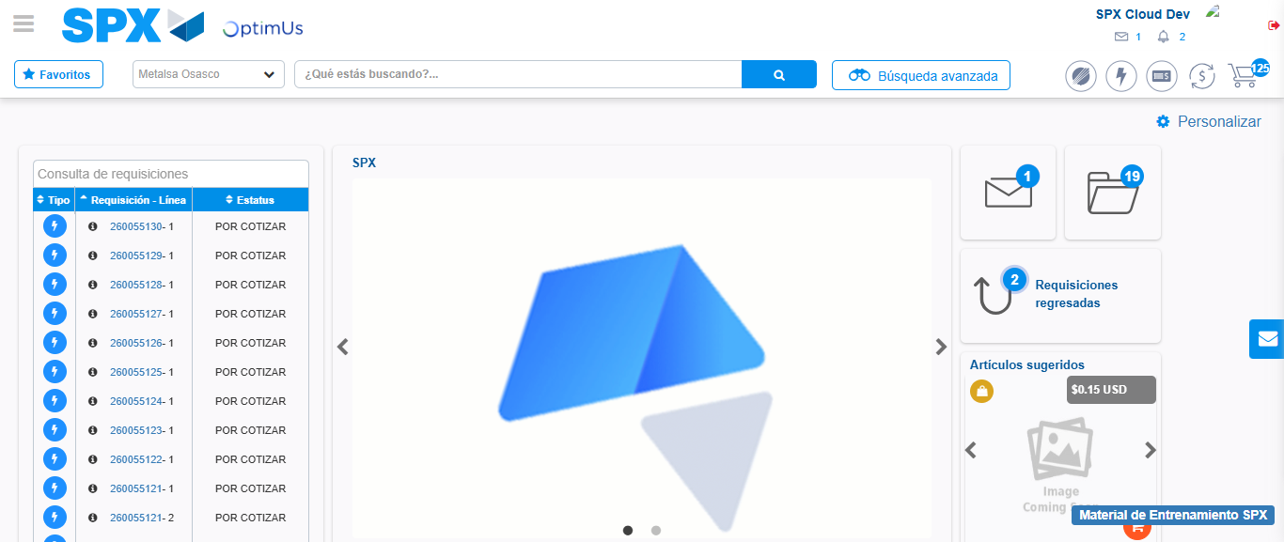Image file-name: QC_Testing-tc002_SPX_Dev5_Crear_Requisicion_Spot_Con_FAD_Tipo_Cobro_CC-1790175393050

